EXE : 10
DATE: 23.11.2020

AIM:
To write a Python function that accepts a string and calculate the number of upper-case letters and lower-case letters.
PROGRAM:
def string(s):
d={"UPPER_CASE":0,"LOWER_CASE":0}
for c in s:
if c.isupper():
d["UPPER_CASE"]+=1
elif c.islower():
d["LOWER_CASE"]+=1
else:
pass
print("No. of Upper case characters: ",d["UPPER_CASE"])
print("No. of Lower case characters: ",d["LOWER_CASE"])
s=input()
string(s)
LINK:
http://103.53.53.18/mod/vpl/forms/submissionview.php?id=325&userid=1757

OUTPUT:
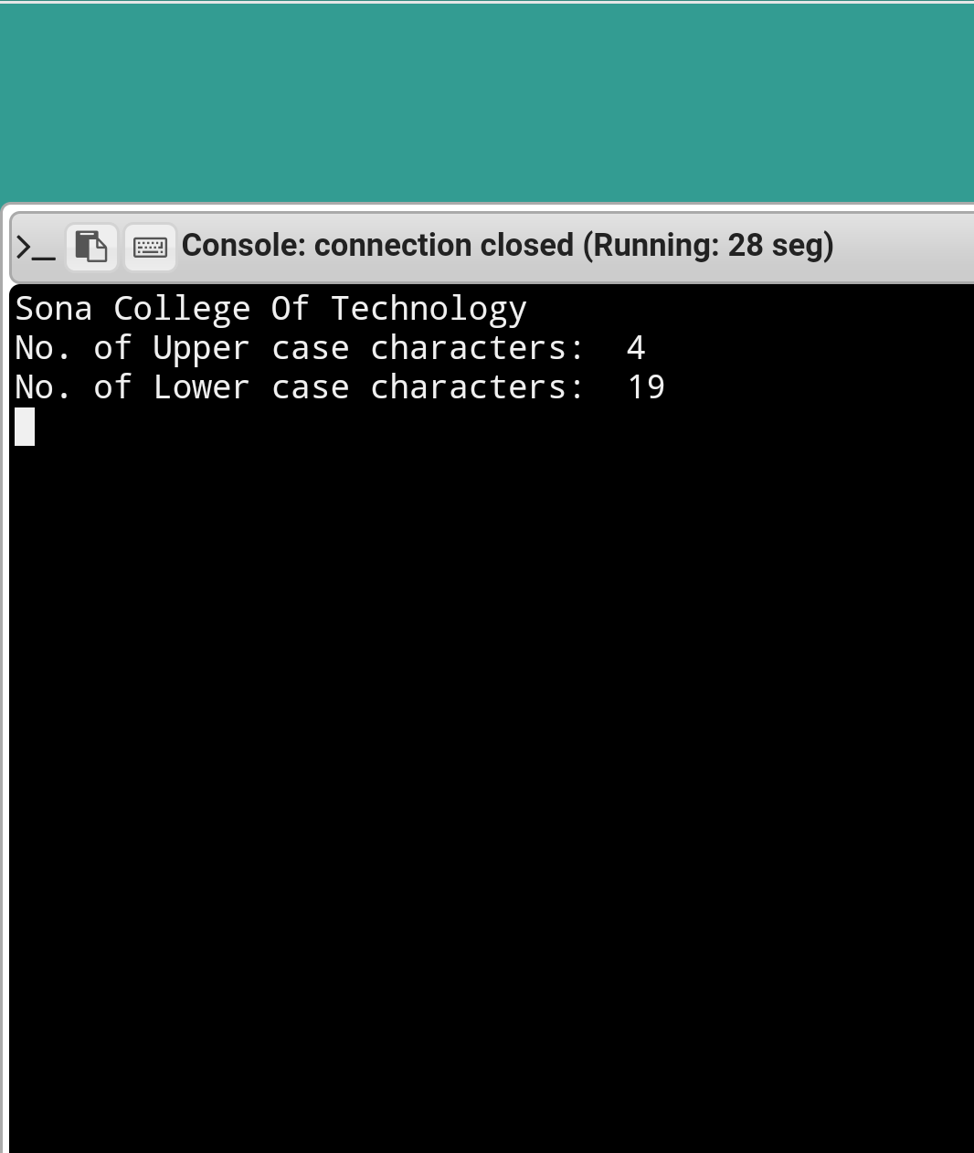

RESULT:
The output of the program is verified successfully.

